|  |  |
| --- | --- |
| Date: 14th Jan 2022 | Name: Rohan Khurana |
|  | Roll No: 1802910129 |

**Distributed System Lab**

**(KCS751A)**

**External Practical**

**Aim:** Simulate the functioning of Lamport’s logical Clock

**Program:**

#include <bits/stdc++.h>

using namespace std;

int max1(int a, int b)

{

    if (a > b)

        return a;

    else

        return b;

}

void display(int e1, int e2, int p1[5], int p2[3])

{

    int i;

    cout << "\nThe time stamps of events in P1:\n";

    for (i = 0; i < e1; i++) {

        cout << p1[i] << " ";

    }

    cout << "\nThe time stamps of events in P2:\n";

    for (i = 0; i < e2; i++)

        cout << p2[i] << " ";

}

void lamportLogicalClock(int e1, int e2, int m[5][3])

{

    int i, j, k, p1[e1], p2[e2];

    for (i = 0; i < e1; i++)

        p1[i] = i + 1;

    for (i = 0; i < e2; i++)

        p2[i] = i + 1;

    for (i = 0; i < e2; i++)

        cout << "\te2" << i + 1;

    for (i = 0; i < e1; i++) {

        cout << "\ne1" << i + 1<<"\t";

        for (j = 0; j < e2; j++)

            cout << m[i][j] << "\t";

    }

    for (i = 0; i < e1; i++) {

        for (j = 0; j < e2; j++) {

            if (m[i][j] == 1) {

                p2[j] = max1(p2[j], p1[i] + 1);

                for (k = j + 1; k < e2; k++)

                    p2[k] = p2[k - 1] + 1;

            }

            if (m[i][j] == -1) {

                p1[i] = max1(p1[i], p2[j] + 1);

                for (k = i + 1; k < e1; k++)

                    p1[k] = p1[k - 1] + 1;

            }

        }

    }

    display(e1, e2, p1, p2);

}

int main()

{

    int e1 = 5, e2 = 3, m[5][3];

    m[0][0] = 0; m[0][1] = 0;

    m[0][2] = 0; m[1][0] = 0;

    m[1][1] = 0; m[1][2] = 1;

    m[2][0] = 0; m[2][1] = 0;

    m[2][2] = 0; m[3][0] = 0;

    m[3][1] = 0; m[3][2] = 0;

    m[4][0] = 0; m[4][1] = -1;

    m[4][2] = 0;

    lamportLogicalClock(e1, e2, m);

    return 0;

}

**Output:**

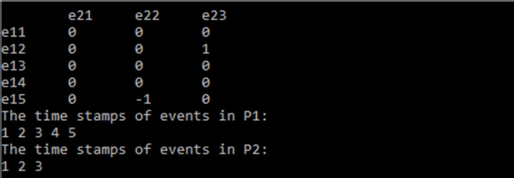

|  |  |
| --- | --- |
| Date: 25th Sept 2021 | Name: Rohan Khurana |
|  | Roll No: 1802910129 |

**Distributed System Lab**

**LAB - 3**

**Aim:** WAP to implement Vector Clock

**Program:**

#include<iostream>

#include<conio.h>

#define SIZE 10

using namespace std;

class node {

public:

int data[SIZE];

node *next;

node() {

for(int p=0; p<SIZE; p++) {

data[p] = 0;

}

next = NULL;

}

node(int v[], int n1) {

for(int s = 0; s < n1; s++) {

data[s] = v[s];

}

next = NULL;

}

friend class process;

}*start=NULL;

int main() {

int n, events, sent, receive, sentE, recE, commLines = 0;

node *temp;

node *proc[SIZE];

cout<<"Enter no. of processes: ";

cin>>n;

int vector[n] = {0};

for(int i = 0; i < n; i++) {

for(int v = 0; v < n; v++) {

vector[v] = 0;

}

cout<<"Enter no. of events in process "<<i+1<<": ";

cin>>events;

for(int j = 1; j <= events; j++) {

vector[i] = j;

node *newnode = new node(vector,n);

if(start == NULL) {

start = newnode;

temp = start;

}

else {

temp->next = newnode;

temp = temp->next;

}

}

proc[i] = start;

start = NULL;

}

cout<<"\nEnter the number of communication lines: ";

cin>>commLines;

node *tempS, *tempR;

for(int i = 0; i < commLines; i++) {

cout<<"\nEnter the sending process: ";

cin>>sent;

cout<<"\nEnter the receiving process: ";

cin>>receive;

cout<<"\nEnter the sending event number: ";

cin>>sentE;

cout<<"\nEnter the receiving event number: ";

cin>>recE;

tempS = proc[sent - 1];

tempR = proc[receive - 1];

for(int j = 1; j < sentE; j++)

tempS = tempS->next;

for(int j = 1; j < recE; j++)

tempR = tempR->next;

for(int j = 0; j < n; j++) {

tempR->data[j] = (tempR->data[j] < tempS->data[j]) ? tempS->data[j] : tempR->data[j];

}

}

cout<<"\nThe resulting vectors are:\n\n";

for(int k = 0; k < n; k++) {

cout<<"Process "<<k + 1<<": ";

node *temp1 = proc[k];

while(temp1) {

cout<<"(";

for(int f = 0; f < n - 1; f++)

cout<<temp1->data[f]<<",";

cout<<temp1->data[n-1];

cout<<")";

temp1 = temp1->next;

}

cout<<endl;

}

return 0;

}

|  |  |
| --- | --- |
| Date: 03rd Dec 2021 | Name: Rohan Khurana |
|  | Roll No: 1802910129 |

**Distributed System Lab**

**LAB – 8**

**Aim:** Implement ‘Java RMI’ mechanism for accessing methods of remote systems.

**Programs:**

1. **Remote Interface**

import java.rmi.Remote;

import java.rmi.RemoteException;

public interface Hello extends Remote {

void printMsg() throws RemoteException;

}

1. **Implementation Class**

public class ImplExample implements Hello {

public void printMsg() {

System.out.println("This is an example RMI program");

}

}

1. **Server Program**

import java.rmi.registry.Registry;

import java.rmi.registry.LocateRegistry;

import java.rmi.RemoteException;

import java.rmi.server.UnicastRemoteObject;

public class Server extends ImplExample {

public Server() {}

public static void main(String args[]) {

try {

ImplExample obj = new ImplExample();

Hello stub = (Hello) UnicastRemoteObject.exportObject(obj, 0);

Registry registry = LocateRegistry.getRegistry();

registry.bind("Hello", stub);

System.err.println("Server ready");

} catch (Exception e) {

System.err.println("Server exception: " + e.toString());

e.printStackTrace();

}

}

}

1. **Client Program**

import java.rmi.registry.LocateRegistry;

import java.rmi.registry.Registry;

public class Client {

private Client() {}

public static void main(String[] args) {

try {

Registry registry = LocateRegistry.getRegistry(null);

Hello stub = (Hello) registry.lookup("Hello");

stub.printMsg();

} catch (Exception e) {

System.err.println("Client exception: " + e.toString());

e.printStackTrace();

}

}

}

**Output:**

RMI Registry

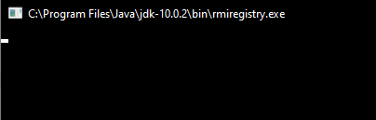

Client.exe

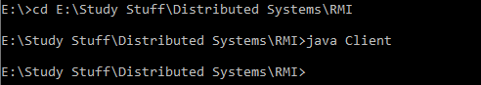

Server.exe

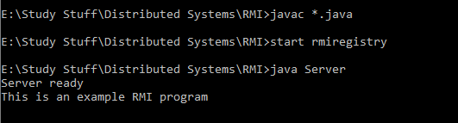

|  |  |
| --- | --- |
| Date: 03rd Dec 2021 | Name: Rohan Khurana |
|  | Roll No: 1802910129 |

**Distributed System Lab**

**LAB – 9**

**Aim:** Simulate Balanced Sliding Window Protocol in ‘C’.

**Program:**

#include<stdio.h>

int main()

{

    int w,i,f,frames[50];

    printf("Enter window size: ");

    scanf("%d",&w);

    printf("\nEnter number of frames to transmit: ");

    scanf("%d",&f);

    printf("\nEnter %d frames: ",f);

    for(i=1;i<=f;i++)

        scanf("%d",&frames[i]);

    printf("\nWith sliding window protocol the frames will be sent in the following manner (assuming no corruption of frames)\n\n");

    printf("After sending %d frames at each stage sender waits for acknowledgement sent by the receiver\n\n",w);

    for(i=1;i<=f;i++)

    {

        if(i%w==0)

        {

            printf("%d\n",frames[i]);

            printf("Acknowledgement of above frames sent is received by sender\n\n");

        }

        else

            printf("%d ",frames[i]);

    }

    if(f%w!=0)

        printf("\nAcknowledgement of above frames sent is received by sender\n");

    return 0;

}

**Output:**

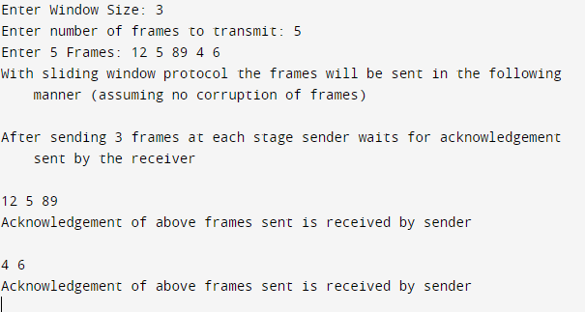

|  |  |
| --- | --- |
| Date: 10th Dec 2021 | Name: Rohan Khurana |
|  | Roll No: 1802910129 |

**Distributed System Lab**

**LAB – 10**

**Aim:** Write a program to implement CORBA mechanism by using C++ program at one end

and Java program on the other.

**Program:**

**Server.cpp**

#include <iostream>

#include "OB/CORBA.h"

#include <OB/Cosnaming.h>

#include "crypt.h"

#include "cryptimpl.h"

using namespace std;

int main(int argc, char** argv)

{

// Declare ORB and servant object

CORBA::ORB_var orb;

CryptographicImpl* CrypImpl = NULL;

try {

// Initialize the ORB.

orb = CORBA::ORB_init(argc, argv);

// Get a reference to the root POA

CORBA::Object_var rootPOAObj =

orb->resolve_initial_references("RootPOA");

// Narrow it to the correct type

PortableServer::POA_var rootPOA =

PortableServer::POA::_narrow(rootPOAObj.in());

// Create POA policies

CORBA::PolicyList policies;

policies.length(1);

policies[0] =

rootPOA->create_thread_policy

(PortableServer::SINGLE_THREAD_MODEL);

// Get the POA manager object

PortableServer::POAManager_var manager = rootPOA->the_POAManager();

// Create a new POA with specified policies

PortableServer::POA_var myPOA = rootPOA->create_POA

("myPOA", manager, policies);

// Free policies

CORBA::ULong len = policies.length();

for (CORBA::ULong i = 0; i < len; i++)

policies[i]->destroy();

// Get a reference to the Naming Service root_context

CORBA::Object_var rootContextObj =

orb->resolve_initial_references("NameService");

// Narrow to the correct type

CosNaming::NamingContext_var nc =

CosNaming::NamingContext::_narrow(rootContextObj.in());

// Create a reference to the servant

CrypImpl = new CryptographicImpl(orb);

// Activate object

PortableServer::ObjectId_var myObjID =

myPOA->activate_object(CrypImpl);

// Get a CORBA reference with the POA through the servant

CORBA::Object_var o = myPOA->servant_to_reference(CrypImpl);

// The reference is converted to a character string

CORBA::String_var s = orb->object_to_string(o);

cout << "The IOR of the object is: " << s.in() << endl;

CosNaming::Name name;

name.length(1);

name[0].id = (const char *) "CryptographicService";

name[0].kind = (const char *) "";

// Bind the object into the name service

nc->rebind(name,o);

// Activate the POA

manager->activate();

cout << "The server is ready.

Awaiting for incoming requests..." << endl;

// Start the ORB

orb->run();

} catch(const CORBA::Exception& e) {

// Handles CORBA exceptions

cerr << e << endl;

}

// Decrement reference count

if (CrypImpl)

CrypImpl->_remove_ref();

// End CORBA

if (!CORBA::is_nil(orb)){

try{

orb->destroy();

cout << "Ending CORBA..." << endl;

} catch (const CORBA::Exception& e)

{

cout << "orb->destroy() failed:" << e << endl;

return 1;

}

}

return 0;

}

**Client.cpp**

#include <iostream>

#include <string>

#include "OB/CORBA.h"

#include "OB/Cosnaming.h"

#include "crypt.h"

using namespace std;

int main(int argc, char** argv)

{

// Declare ORB

CORBA::ORB_var orb;

try {

// Initialize the ORB

orb = CORBA::ORB_init(argc, argv);

// Get a reference to the Naming Service

CORBA::Object_var rootContextObj =

orb->resolve_initial_references("NameService");

CosNaming::NamingContext_var nc =

CosNaming::NamingContext::_narrow(rootContextObj.in());

CosNaming::Name name;

name.length(1);

name[0].id = (const char *) "CryptographicService";

name[0].kind = (const char *) "";

// Invoke the root context to retrieve the object reference

CORBA::Object_var managerObj = nc->resolve(name);

// Narrow the previous object to obtain the correct type

::CaesarAlgorithm_var manager =

::CaesarAlgorithm::_narrow(managerObj.in());

string info_in,exit,dummy;

CORBA::String_var info_out;

::CaesarAlgorithm::charsequence_var inseq;

unsigned long key,shift;

try{

do{

cout << "\nCryptographic service client" << endl;

cout << "----------------------------" << endl;

do{ // Get the cryptographic key

if (cin.fail())

{

cin.clear();

cin >> dummy;

}

cout << "Enter encryption key: ";

cin >> key;

} while (cin.fail());

do{ // Get the shift

if (cin.fail())

{

cin.clear();

cin >> dummy;

}

cout << "Enter a shift: ";

cin >> shift;

} while (cin.fail());

// Used for debug pourposes

//key = 9876453;

//shift = 938372;

getline(cin,dummy); // Get the text to encrypt

cout << "Enter a plain text to encrypt: ";

getline(cin,info_in);

// Invoke first remote method

inseq = manager->encrypt

(info_in.c_str(),key,shift);

cout << "------------------------------------------"

<< endl;

cout << "Encrypted text is: "

<< inseq->get_buffer() << endl;

// Invoke second remote method

info_out = manager->decrypt(inseq.in(),key,shift);

cout << "Decrypted text is: "

<< info_out.in() << endl;

cout << "-------------------------------------------"

<< endl;

cout << "Exit? (y/n): ";

cin >> exit;

} while (exit!="y");

// Shutdown server message

manager->shutdown();

} catch(const std::exception& std_e){

cerr << std_e.what() << endl;

}

}catch(const CORBA::Exception& e) {

// Handles CORBA exceptions

cerr << e << endl;

}

// End CORBA

if (!CORBA::is_nil(orb)){

try{

orb->destroy();

cout << "Ending CORBA..." << endl;

} catch(const CORBA::Exception& e)

{

cout << "orb->destroy failed:" << e << endl;

return 1;

}

}

return 0;

}